**Capstone Submission**

Github repo url(master branch): <https://github.com/Balaa2801/devops-build>

Github repo url (dev branch): <https://github.com/Balaa2801/devops-build/tree/dev>

Deployed site url: <http://3.108.42.146:80>

Jenkins url: <http://3.108.42.146:8080>

Docker Image Name : build_web (ID 08fa8702cf14)

docker image id: 08fa8702cf14 (prod) 562d5c8f88f0 (dev)

**Screenshots**

Jenkins login page

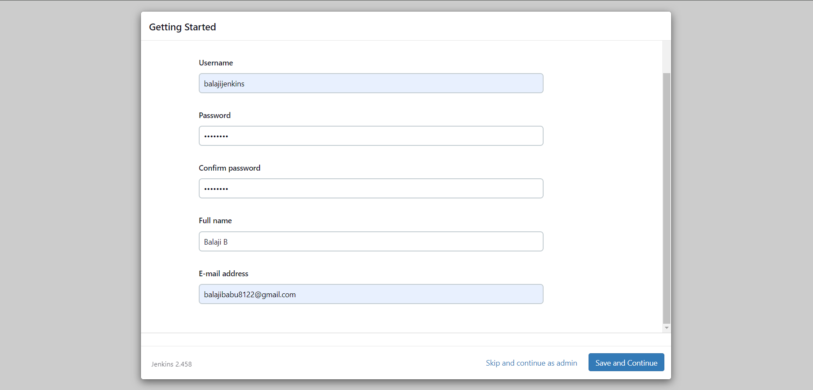

**Jenkins page**

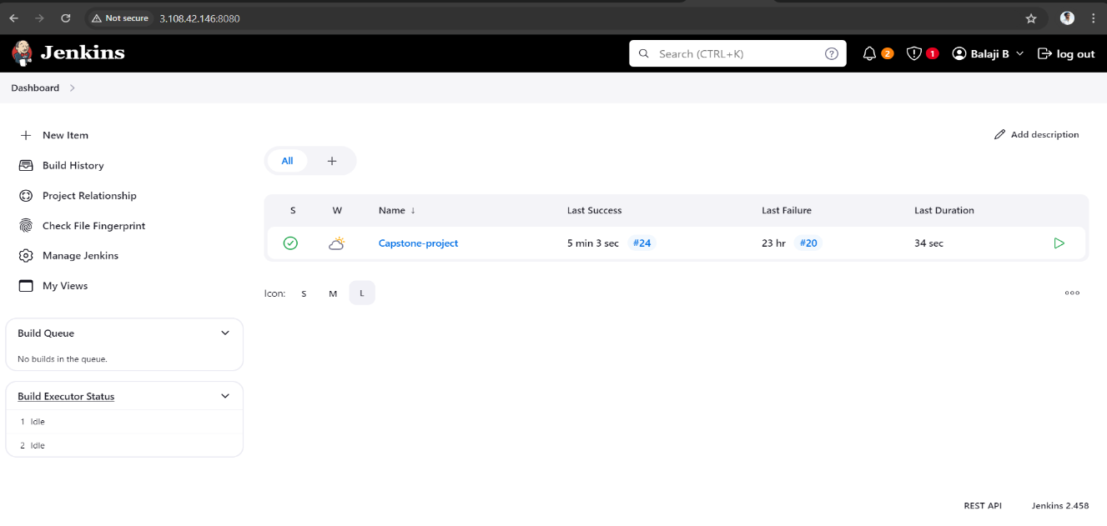

**Jenkins configuration**

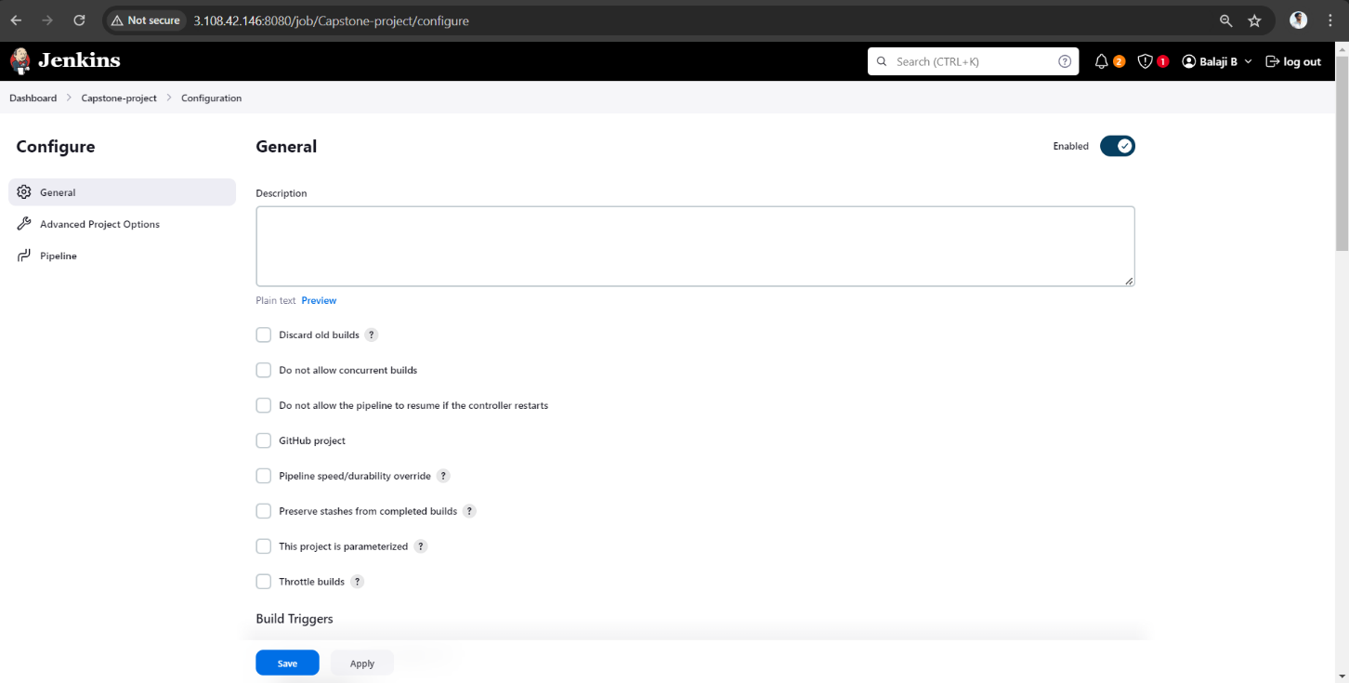

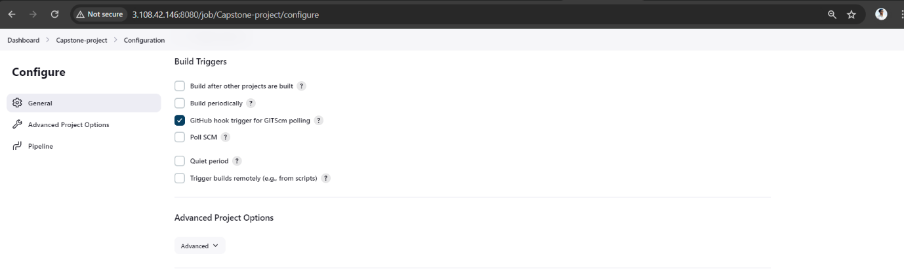

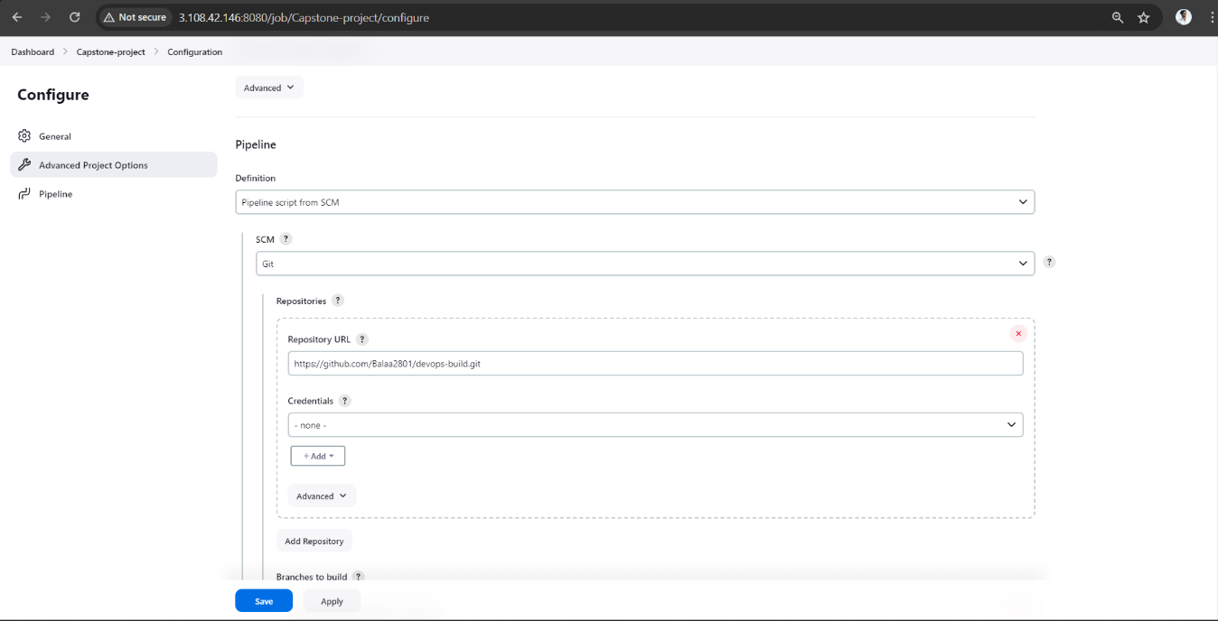

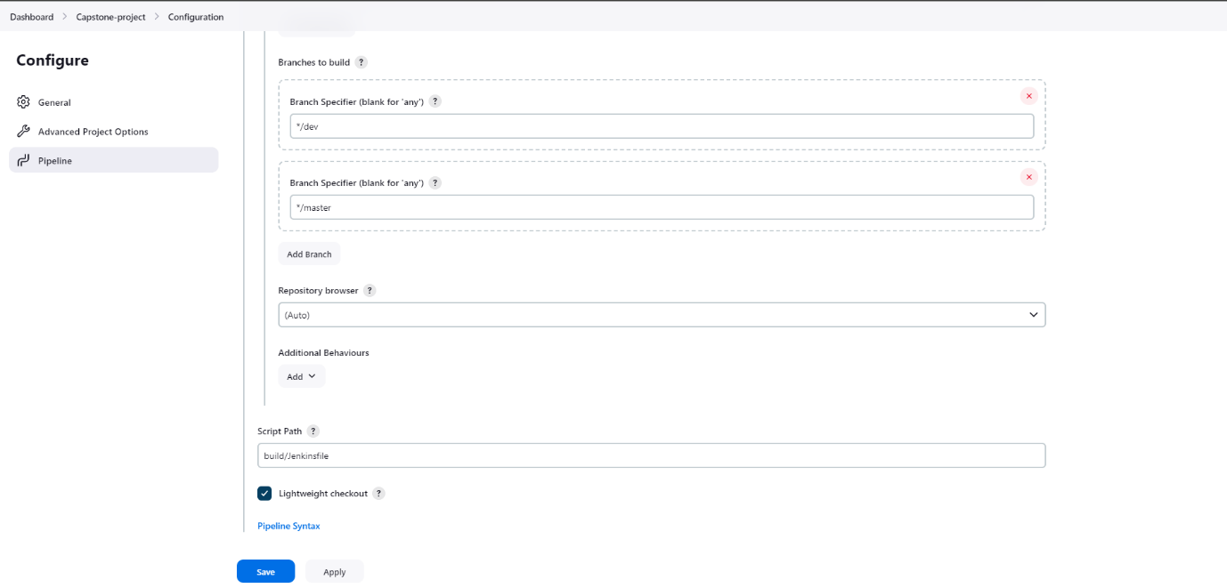

**Aws console**

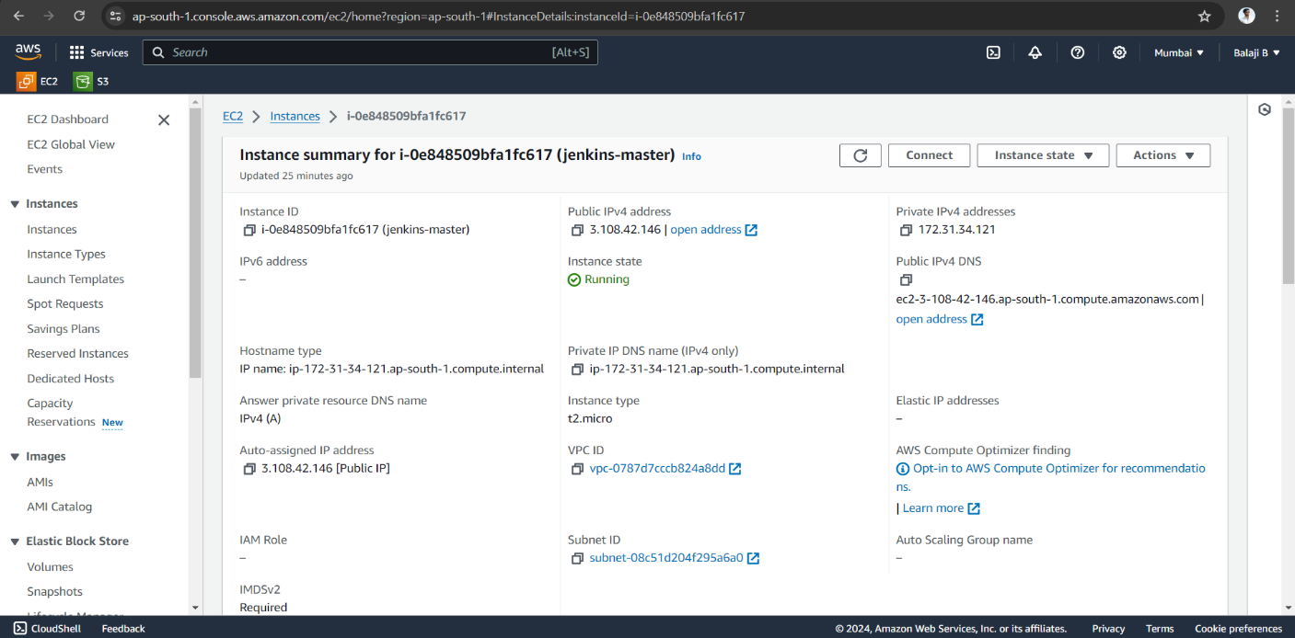

**AWS SG configs**

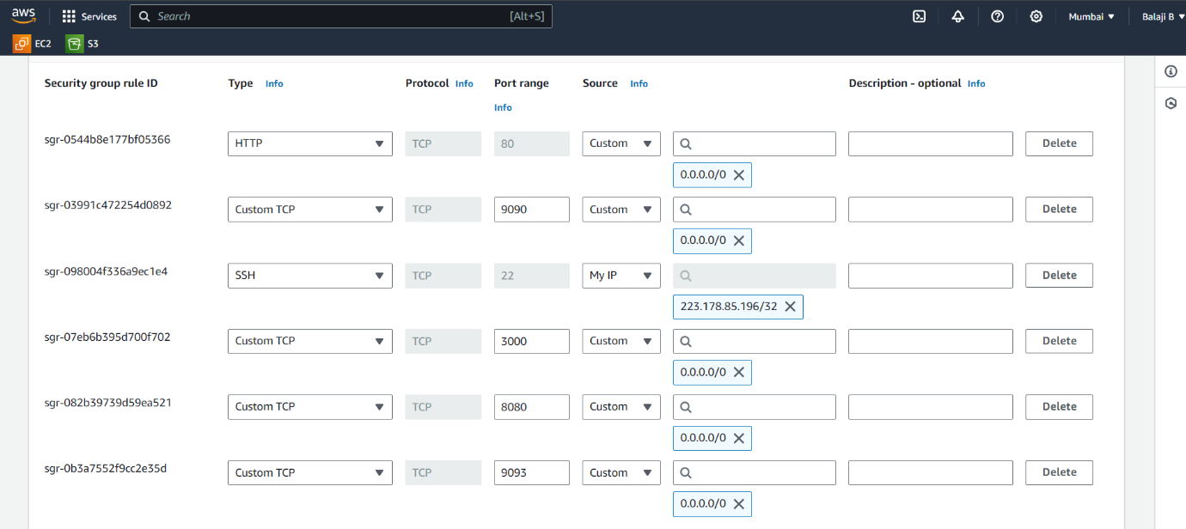

**Dockerhub repos**

**DEV repo**

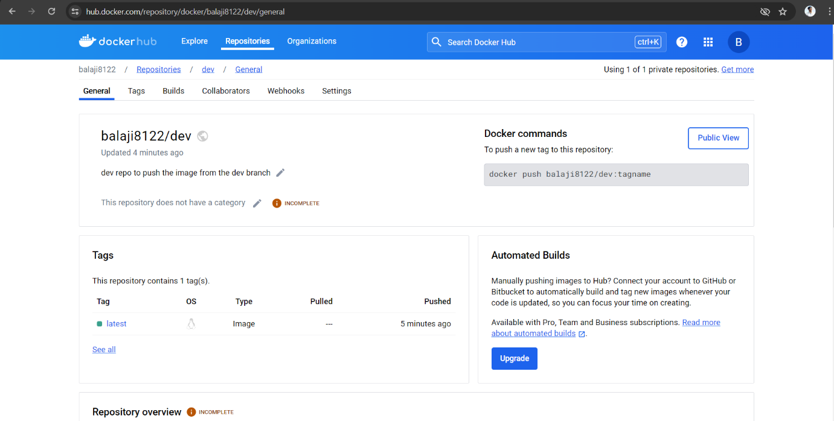

**PROD repo**

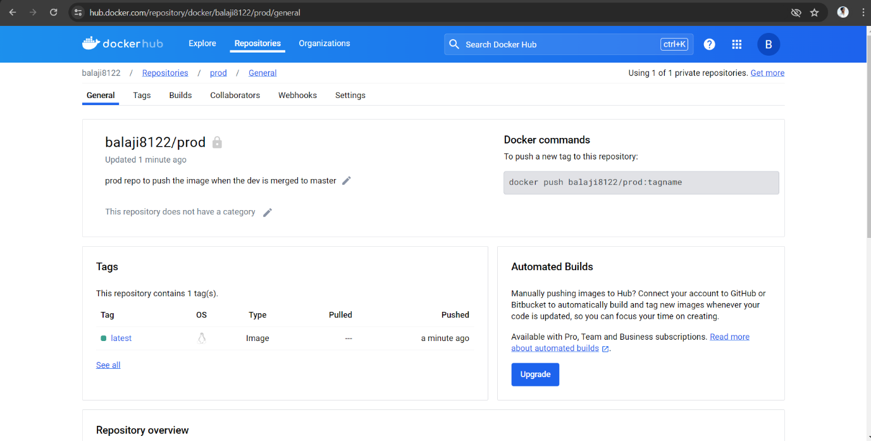

**Deployed site page**

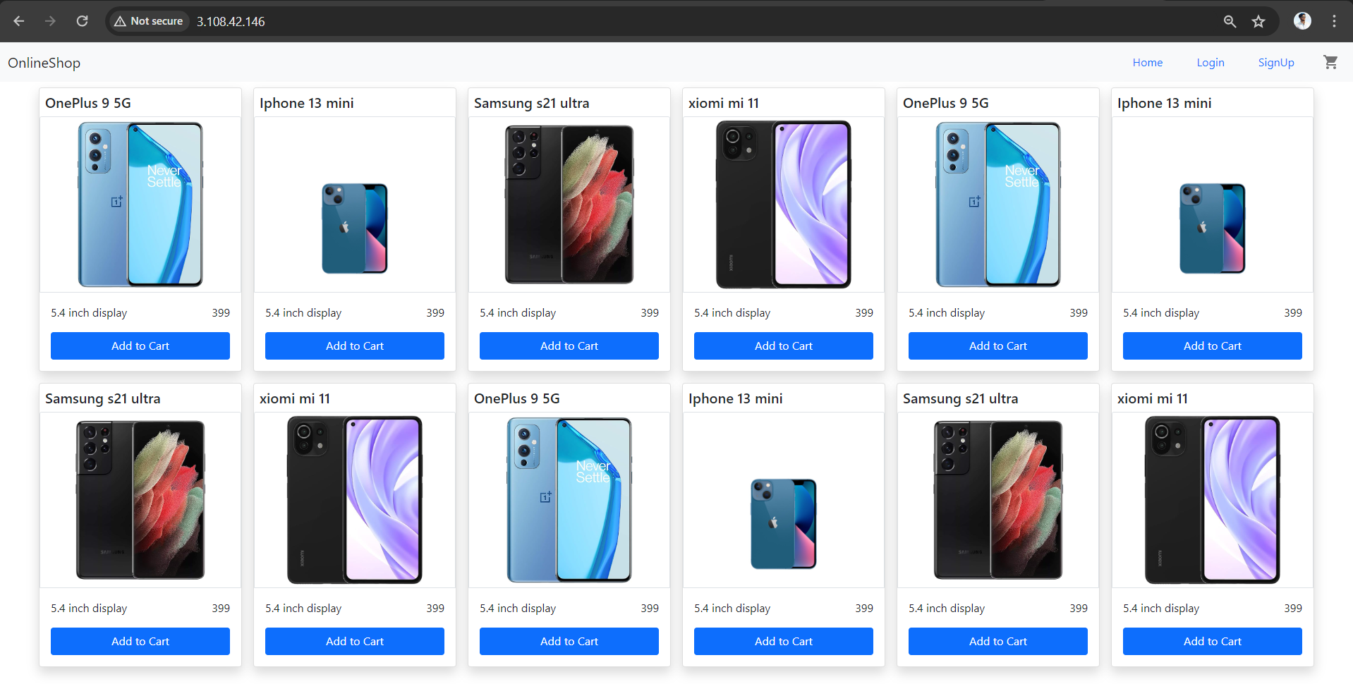

**Monitoring health check status**

**Grafana**

